Go to www.khanacademy.org & sign in with facebook, google, or sign up with e-mail.
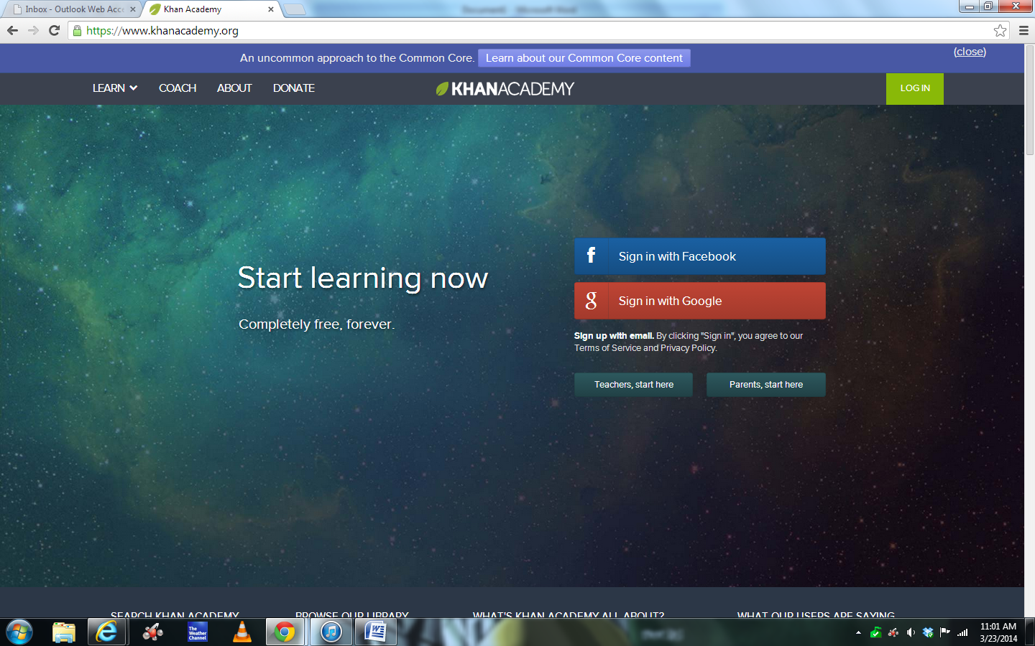
Click on “Start your learning adventure” at the bottom of the video.
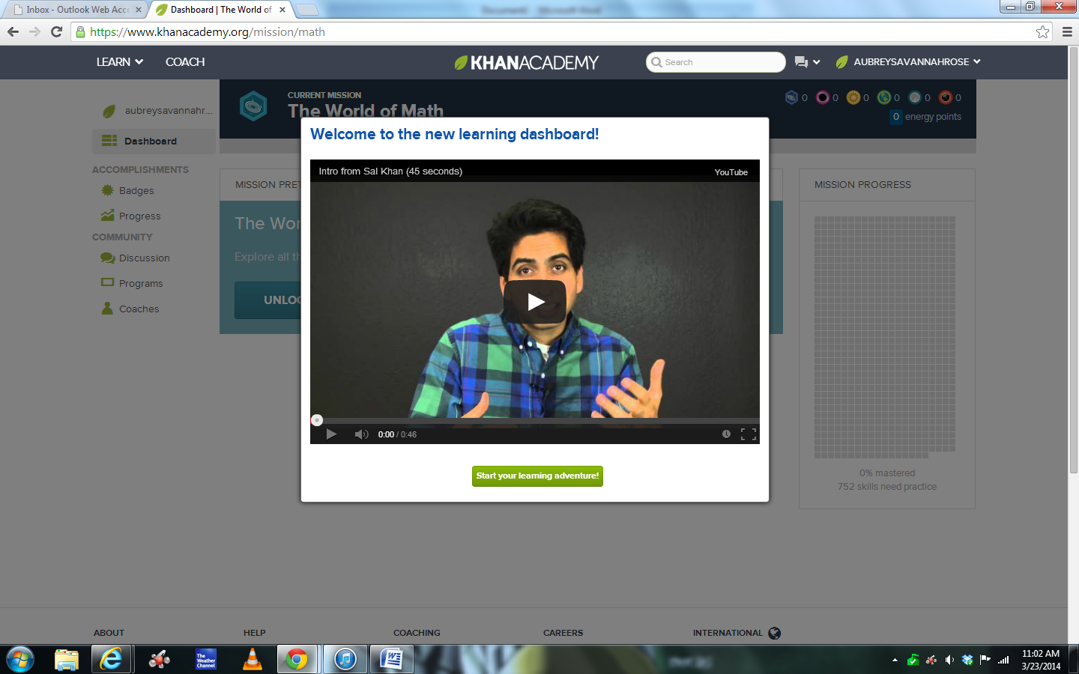
Read and then click “got it”.
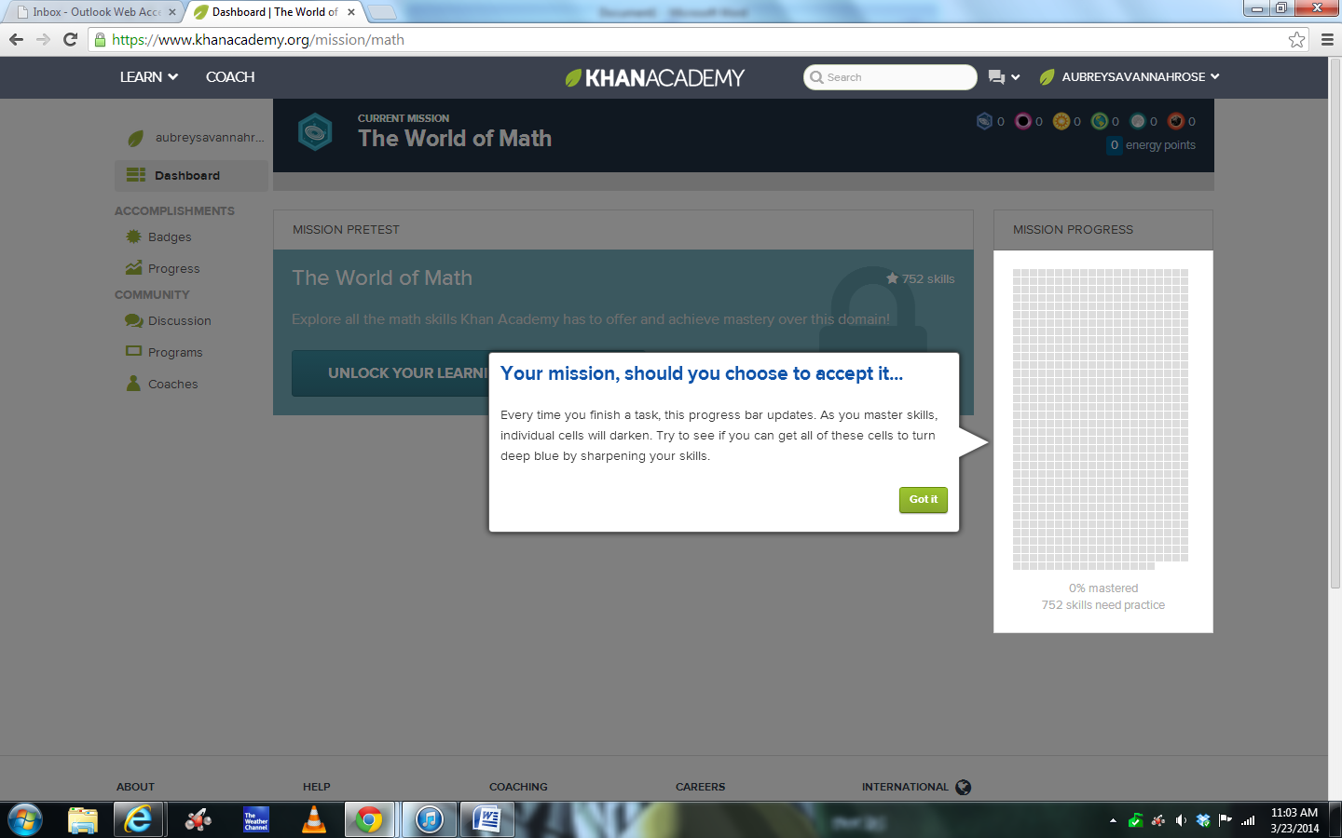
Sign up with me as your coach. Click on “Coaches” at the bottom of the list on the left. Enter the class code of WM7C4A.
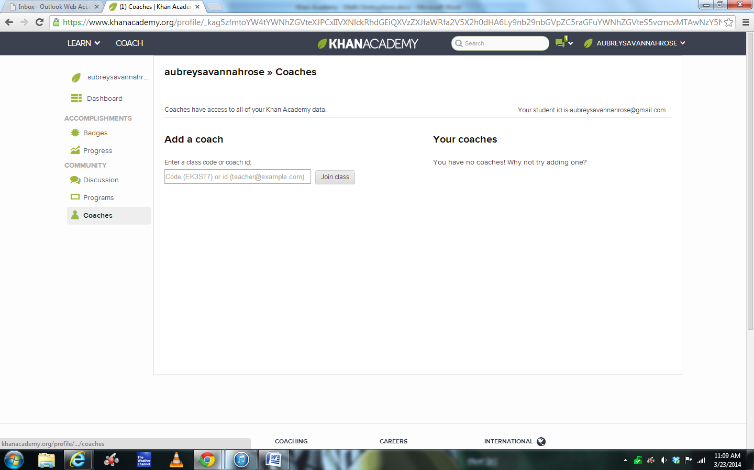
It will now show me as your coach and I will be able to see your progress.
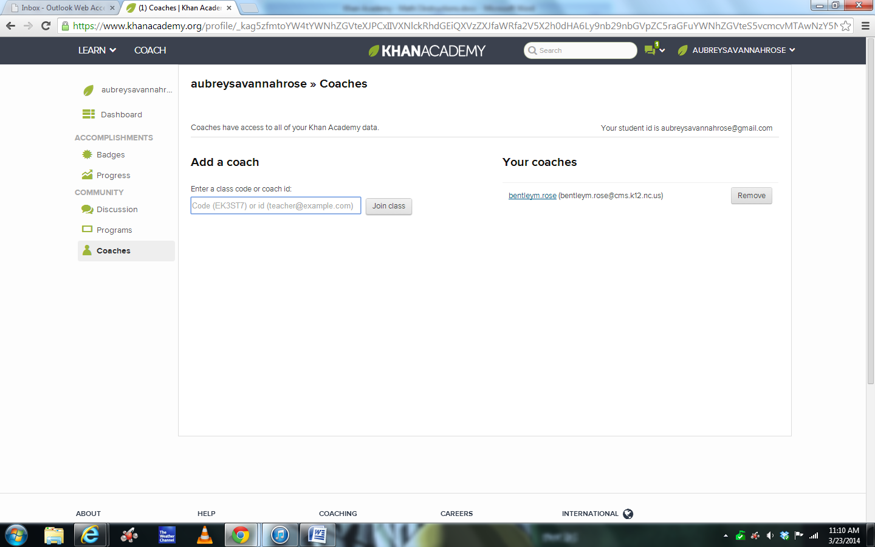
Click back on “dashboard” on the list at the left. Then, take the pretest
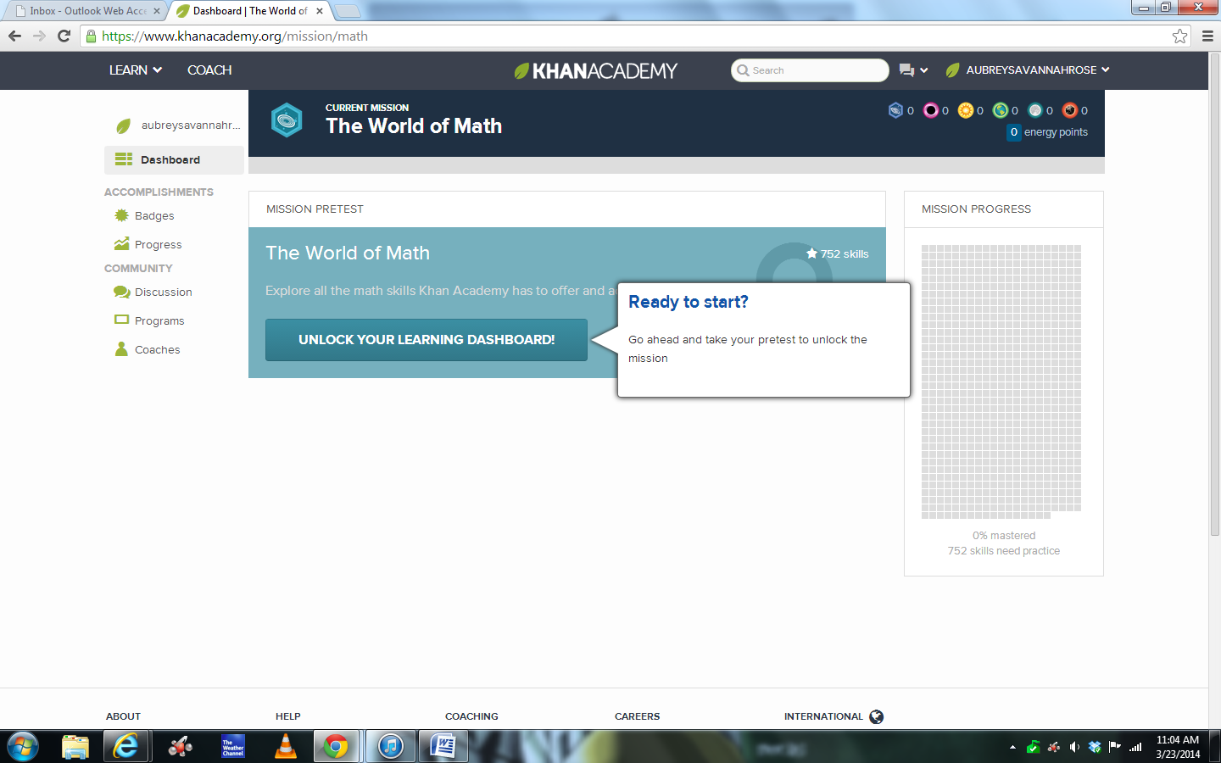
After you finish the pretest, close the task summary by clicking the green button.
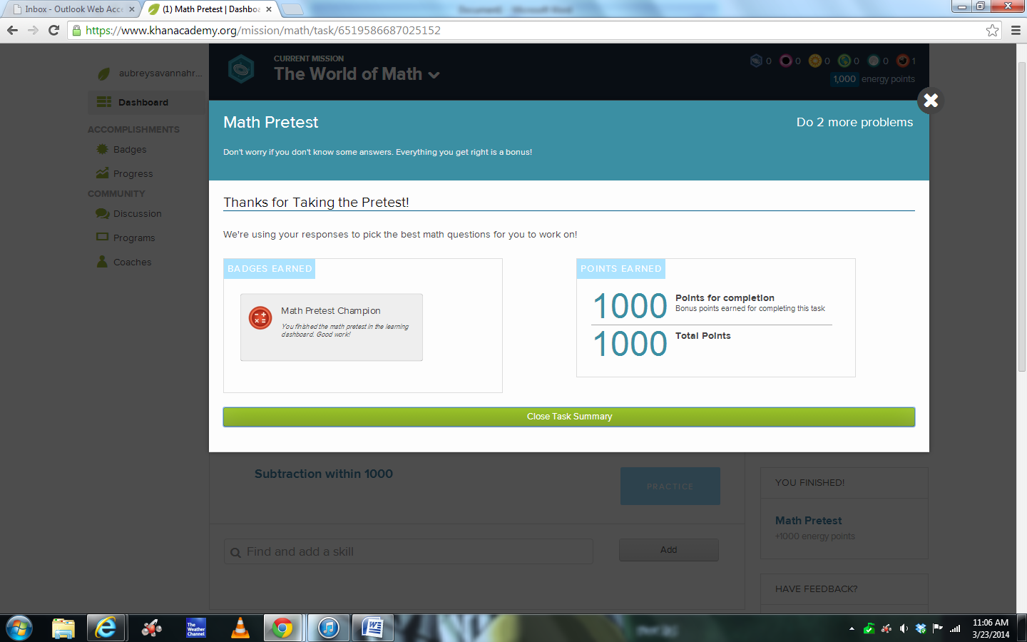
Click on the world of math at the top and select your new mission as Algebra I.
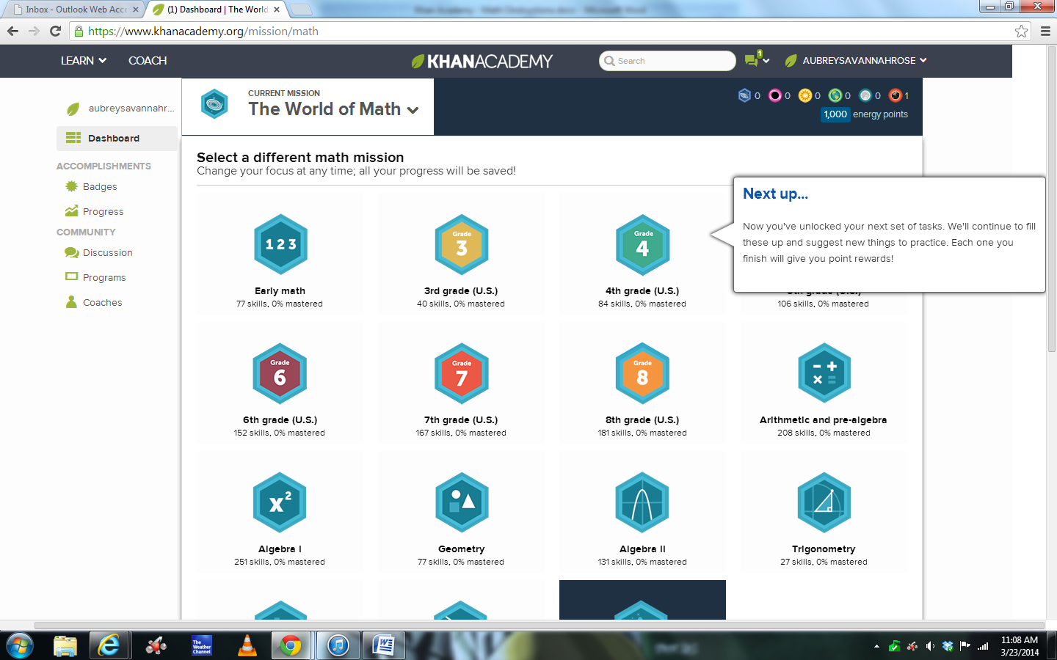
Do the mastery challenge several times. It will start easy and keep getting harder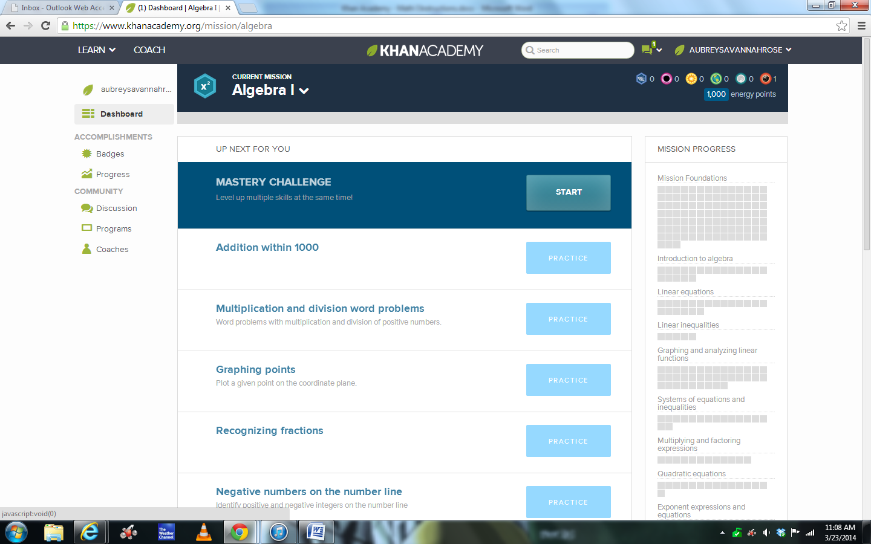
Once you start to show mastery, the boxes on the right will change color. . The more boxes that you fill in, the more you know.
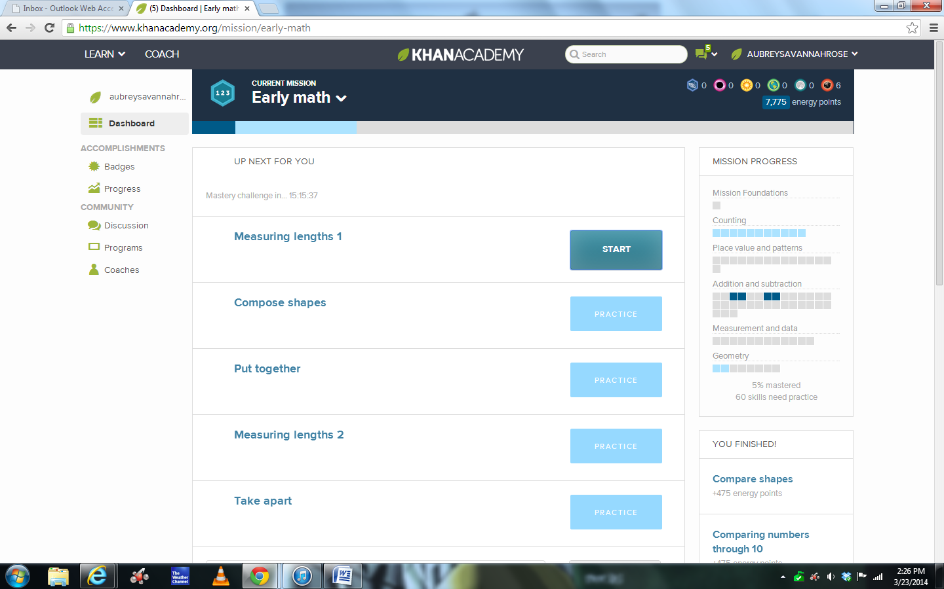
At the top left, click on learn, and then knowledge map.
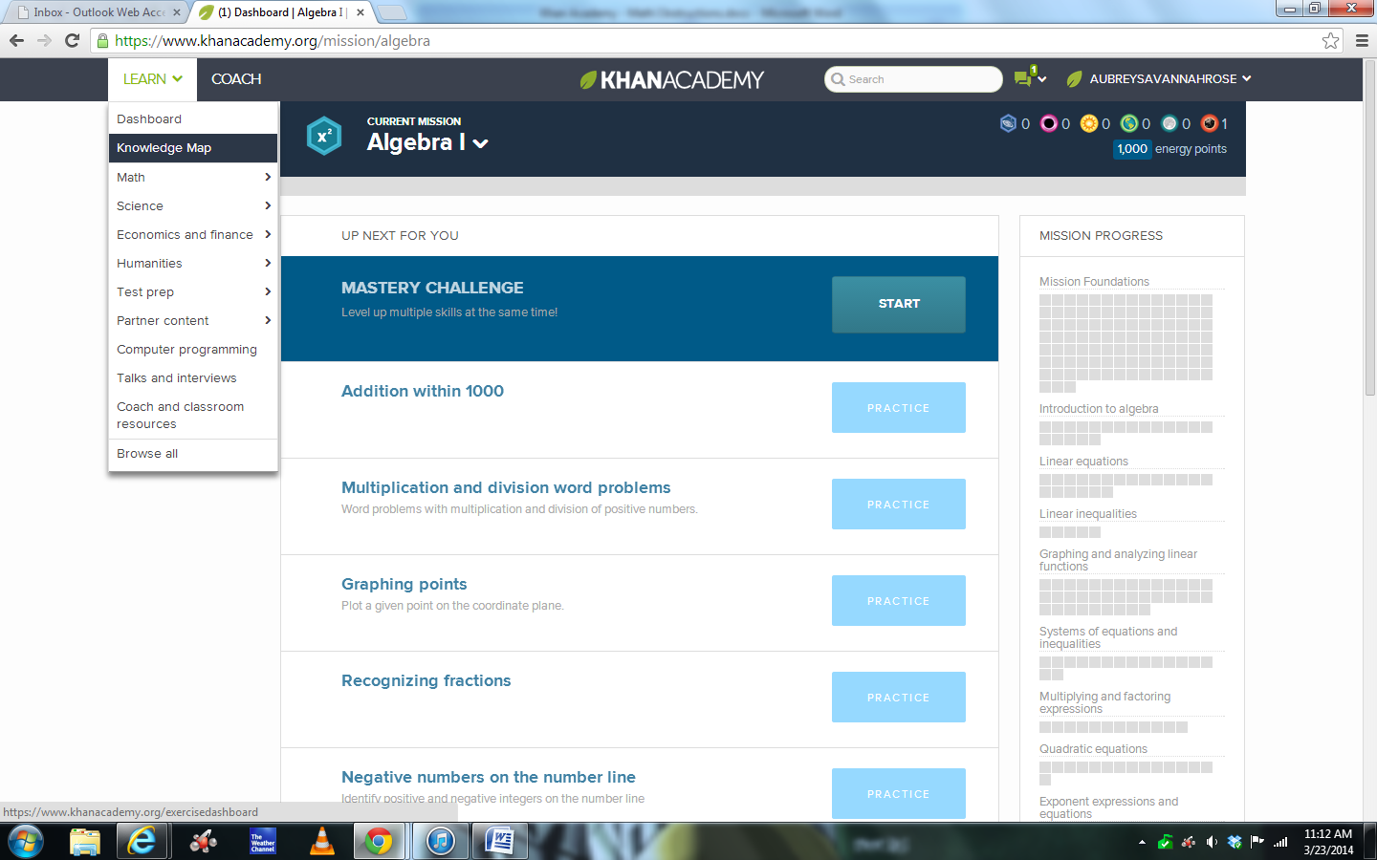
You can zoom in and see lots of different topics. Click on a start and try to see if you can master one! Make sure to pick a topic that we have covered so far this year.
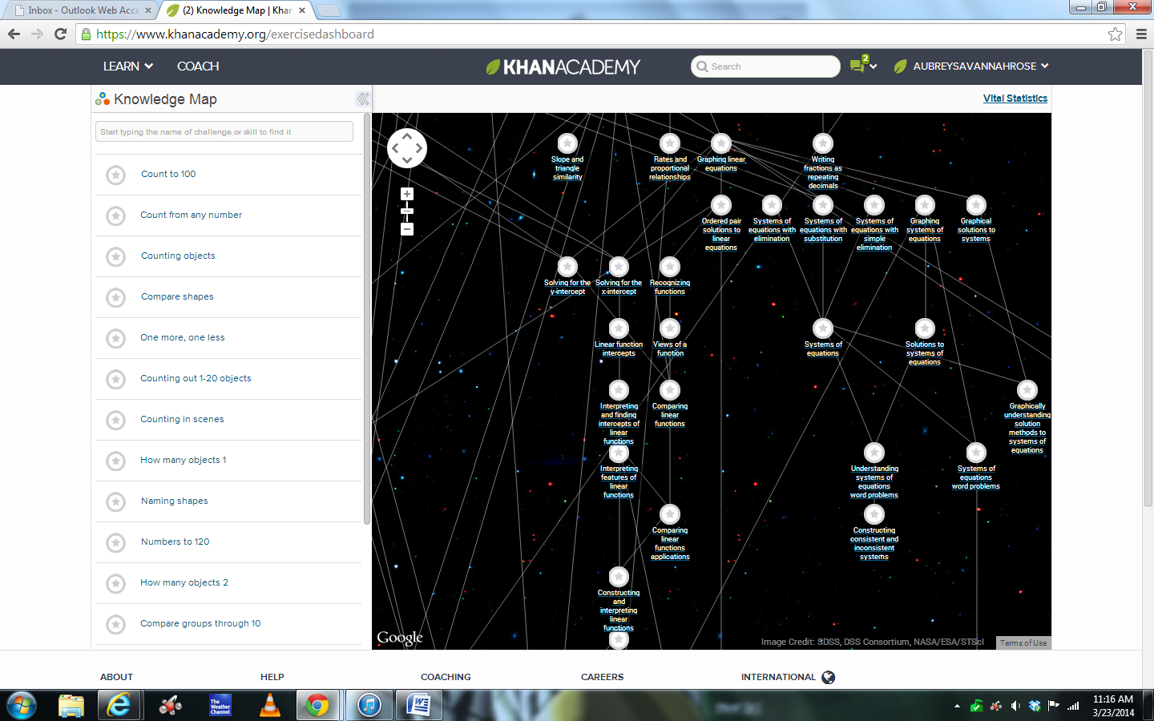
You can also search for a topic in the top left of the knowledge map.
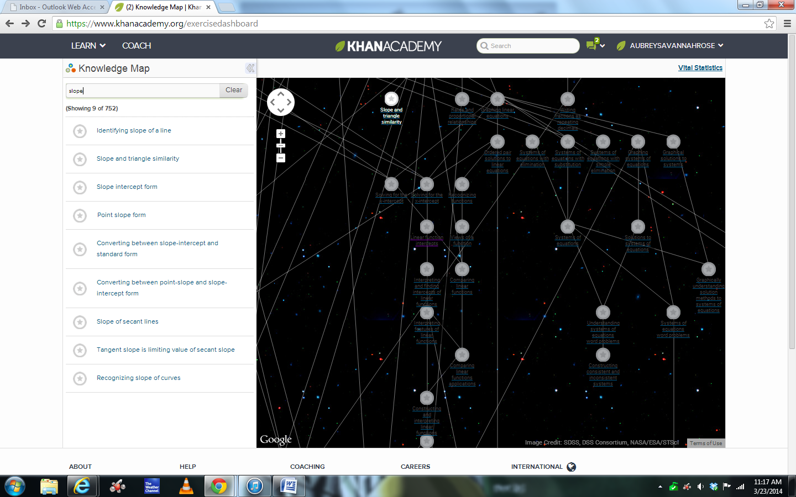

Good topics to search for and practice:
- Identifying slope of a line
- Slope-intercept form
- Point-slope form
- Converting between slope-intercept and standard form
- Converting between point-slope and slope-intercept form
- Search for factoring and choose any of the ones that come up!
- Search for systems of equations and choose any of the ones that come up!
- Distance formula.

The circles on the knowledge map will turn blue as well when you search for and show mastery of topics.
